Use This Format for Abstract Titles for Indaba 10 by Selecting Each Section and Replacing it with New Text
Peter Lionª, Paul Buffalo^{b} and Mary Cheetahª
ª Department of Chemistry, University of Atlantis, Atlantis 0000, E-mail: first@univ.ac.za
^{b} School of Molecular Biology, University of the Free State, Bloemfontein 9300, South Africa
The abstracts for Indaba 10 should be submitted in the format of this document. They will thus be an A4 page with 2.5 cm margins all round. The preferred font is Calibri, single spaced. The abstract including the title, author affiliations, and any references should not exceed one page: if they do they will not be accepted and will be returned to the author(s) for further editing and resubmission.
Fonts and Formatting. Please retain the fonts and paragraph settings in this template: Title 14pt, authors 12 pt, affiliations 10 pt, abstract body 11 pt, figure captions (centered) 10pt. Do not edit or add anything to the Header/Footer fields in the document.
Title. Only two lines for the title are strongly recommended.
Authors. Please use superscript letters to indicate author affiliations as shown in the format above. The presenting author’s name must be underlined and his/her e-mail address included after the relevant address.
Structure Block/Scheme. A ChemDraw, ISISDraw, ChemWindows or ChemSketch figure that summarizes the compound(s) studied or depicts the work undertaken must be copied and pasted in the frame as indicated in this template. ORTEP or other high-quality diagrams are also acceptable.
The abstracts will be published electronically only, so color figures can be in color.
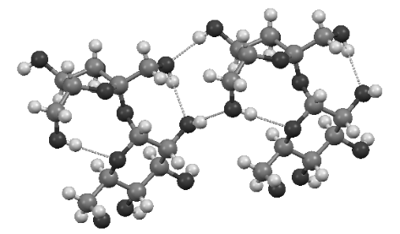

Figure 1: Hydrogen bonded sucrose molecules

The first line of each paragraph should not be indented and there should be no blank lines between paragraphs.
References (if any) should be indicated by numbers in square brackets [1], [2]…etc. in the text and be given at the end of the abstract [1] below the footnote line in 10pt font.

[1] Lion, P; Buffalo, P; Cheetah, M. SkukuzaCommunications., 2014, 25, 123-456.

